

SECV2113 HUMAN COMPUTER INTERACTION

ASSIGNMENT 1

NAME | MATRIC ID
AFIF SHAQIR IRFAN BIN ARQAM | A23CS0204
AHMAD ZIYAAD BIN MOHD ABBAS | A23CS0206
NURUL ADRIANA BINTI KAMAL JEFRI | A23CS0258

LECTURER’S NAME: DR NUR ZURAIFAH SYAZRAH OTHMAN

DATE OF SUBMISSION: 20 APRIL 2024

INTRODUCTION

The United Nations created the 17 Sustainable Development Goals (SDGs) in 2015 as a global call to action to eradicate poverty, safeguard the environment, and guarantee prosperity for all by the year 2030. Below here is a synopsis of each objective:
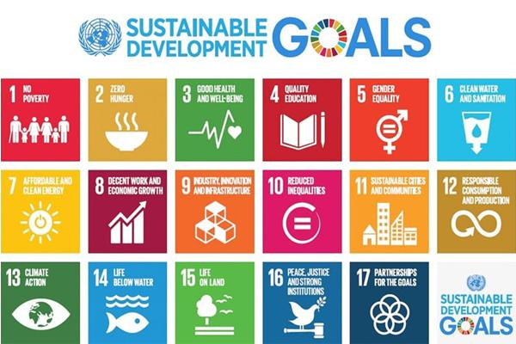
1. No Poverty: End poverty in all its forms everywhere.
2. Zero Hunger: End hunger, achieve food security and improved nutrition, and promote sustainable agriculture.
3. Good Health and Well-being: Ensure healthy lives and promote well-being for all at all ages.
4. Quality Education: Ensure inclusive and equitable quality education and promote lifelong learning opportunities for all.
5. Gender Equality: Achieve gender equality and empower all women and girls.
6. Clean Water and Sanitation: Ensure availability and sustainable management of water and sanitation for all.
7. Affordable and Clean Energy: Ensure access to affordable, reliable, sustainable, and modern energy for all.
8. Decent Work and Economic Growth: Promote sustained, inclusive, and sustainable economic growth, full and productive employment, and decent work for all.
9. Industry, Innovation, and Infrastructure: Build resilient infrastructure, promote inclusive and sustainable industrialization, and foster innovation.
10. Reduced Inequality: Reduce inequality within and among countries.
11. Sustainable Cities and Communities: Make cities and human settlements inclusive, safe, resilient, and sustainable.
12. Responsible Consumption and Production: Ensure sustainable consumption and production patterns.
13. Climate Action: Take urgent action to combat climate change and its impacts.
14. Life Below Water: Conserve and sustainably use the oceans, seas, and marine resources for sustainable development.
15. Life on Land: Protect, restore, and promote sustainable use of terrestrial ecosystems, sustainably manage forests, combat desertification, and halt and reverse land degradation and halt biodiversity loss.
16. Peace, Justice, and Strong Institutions: Promote peaceful and inclusive societies for sustainable development, provide access to justice for all, and build effective, accountable, and inclusive institutions at all levels.
17. Partnerships for the Goals: Strengthen the means of implementation and revitalise the global partnership for sustainable development.

These goals provide a framework for global cooperation and action to address the world's most pressing challenges in a comprehensive and interconnected manner.
Our group has chosen the 12th goals ( Responsible Consumption and Production ) as our technology.The main goals of this technology is to encourage sustainable patterns of production and consumption globally. It emphasises the importance of doing more with less, separating economic growth and development from resource consumption and environmental damage.

Key aspects of Responsible Consumption and Production include:
- Sustainable Production: Encouraging industries and businesses to adopt sustainable practices that minimise resource use, waste generation, and environmental impacts throughout the production process.
- Sustainable Consumption: Promoting sustainable lifestyles and consumer behaviour that prioritise the use of environmentally friendly products, reduce waste, and consider the social and environmental impacts of consumption choices.
- Resource Efficiency: Encouraging the efficient use of resources such as water, energy, and raw materials to minimise waste generation and pollution while maximising economic and social benefits.
- Waste Reduction and Management: Implementing strategies to reduce, reuse, and recycle waste to minimise the environmental impact of waste disposal and move towards a circular economy model.
- Supply Chain Sustainability: Ensuring that supply chains are transparent, ethical, and environmentally responsible, from sourcing raw materials to the distribution and disposal of products.
Overall, Responsible Consumption and Production aims to promote sustainable development by fostering more sustainable patterns of consumption and production that meet the needs of the present without compromising the ability of future generations to meet their own needs.

b) 2 specific task/feature to persuade user to execute a “target behaviour”
i.
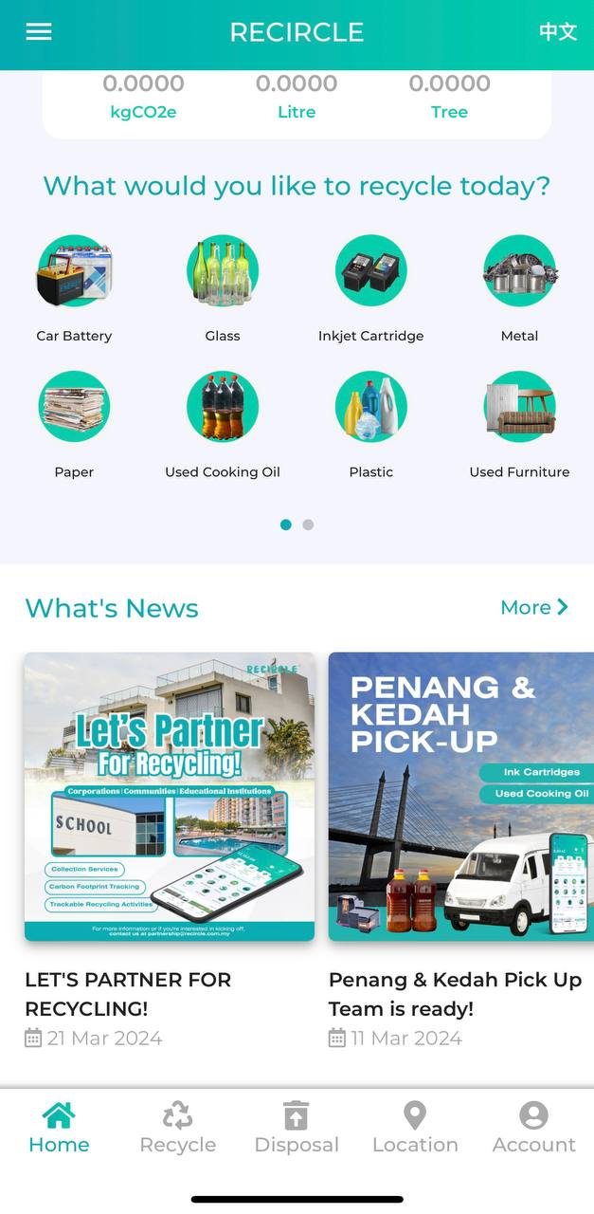
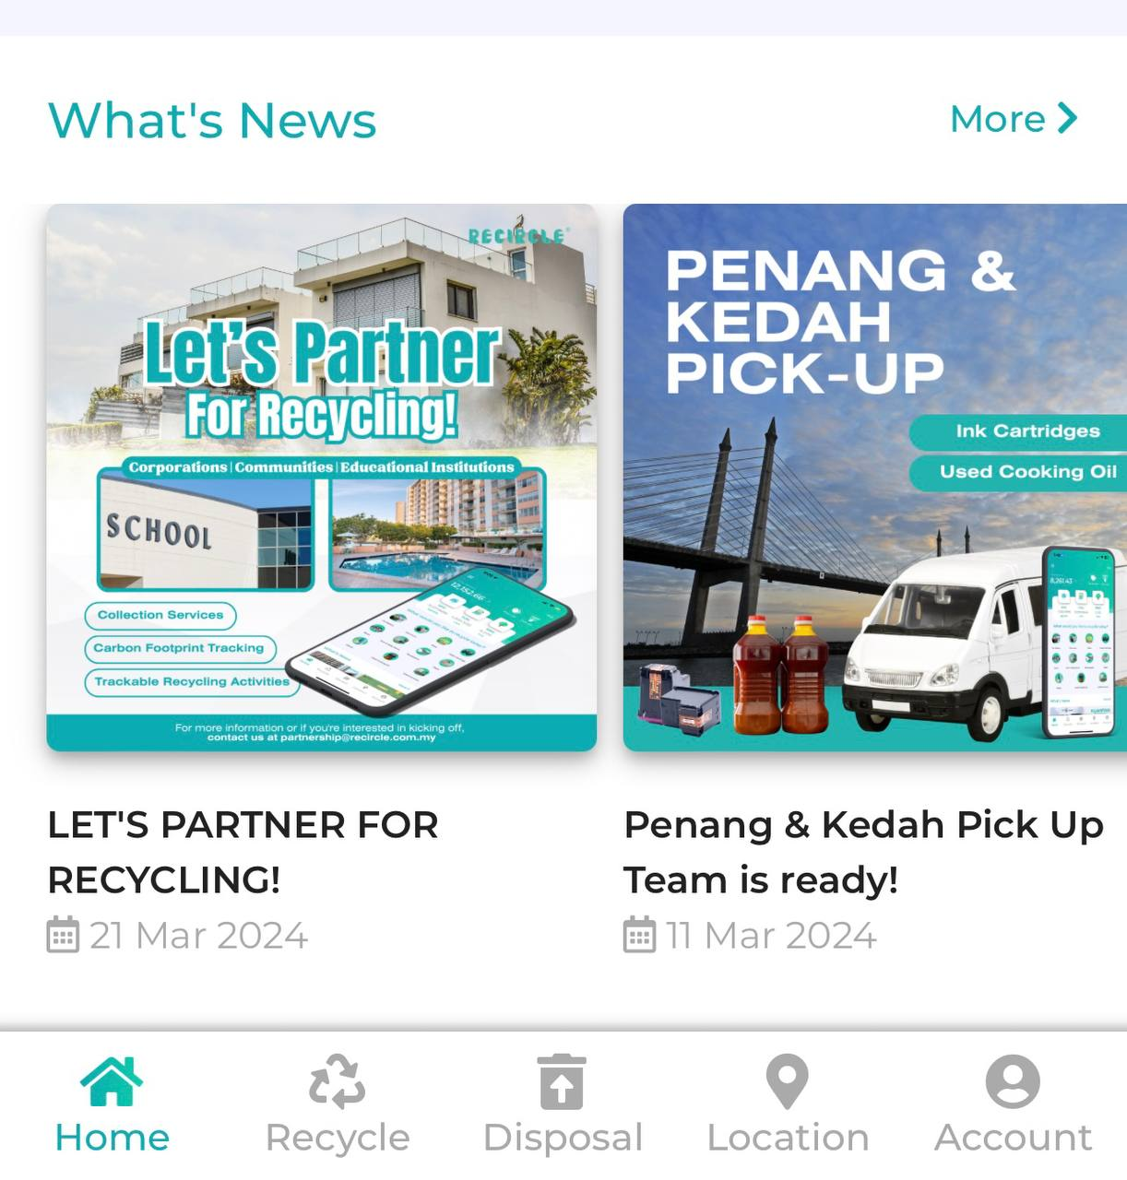
What is the feature?
What’s News (shares about several current information and trends that are related to the recycling industry in Malaysia).

What is the target behaviour?
For users to click on the What’s News section in the app main interface that is directly linked to the fuller page consisting of the newest information about recycling.

- ABILITY
The section of What’s News is quite big on the app main interface, and it snatches the attention from the users. In this part, the physical effort is not much needed. As shown, the users don’t have to open up other apps or websites just to read about the latest news of recycling. This feature is much more simple and has helped the apps to grow quickly since they can directly read the news from the same app by just a click. Other than that, it’s easy as it doesn’t consume too much time. The users could efficiently access this app just to read the news everywhere and anytime. They would be updated with the latest information even when they are eating, waiting or even in public transport. Last but not least, the users don’t have to spend even one cent of their money just to read the news. Basically, people might have to buy a newspaper or magazine, or even subscribe monthly to a news website just to read a small amount of information about recycling issues. Fortunately, this app has included this section especially without any side haste.

- MOTIVATION
Users have high motivation to click on the section that brings them to the What’s News page because of hope and fear. They want to catch up on the latest details of recycling in Malaysia. In hope, they wish that there is more good news about how recycling has saved the world by taking care of the environment from pollution and wastes, protecting its ecosystems and wildlife, conserving natural resources, and reducing carbon emissions. On the good side, recycling brings people together by educating them while also helping them by saving energy and money.

In fear, the users want to avoid the news about how so few people see the importance of recycling to their life and the world itself. The ignorant behaviour of people towards their environment are the root of world collateral damages. Not to mention, the users would be terrified to know how many disadvantages could be brought to the world if people stop recycling, such as increased human health risks, deforestation, overtaxed landfills, uprising pollution and climate changes, destruction to natural habitat and wildlife, and so much more.

- FACILITATOR
In the app, the word "MORE" acts as a guide by being placed next to the headline of the "What's News" section to let users know that there are more recycling-related topics to investigate. Its positioning next to the section title makes it easier for users to learn more about the topic. Because it only requires a single click to encourage consumers, facilitator as a trigger is especially powerful because it doesn't require them to take any more steps or resources beyond what they already have or can easily obtain.

ii.
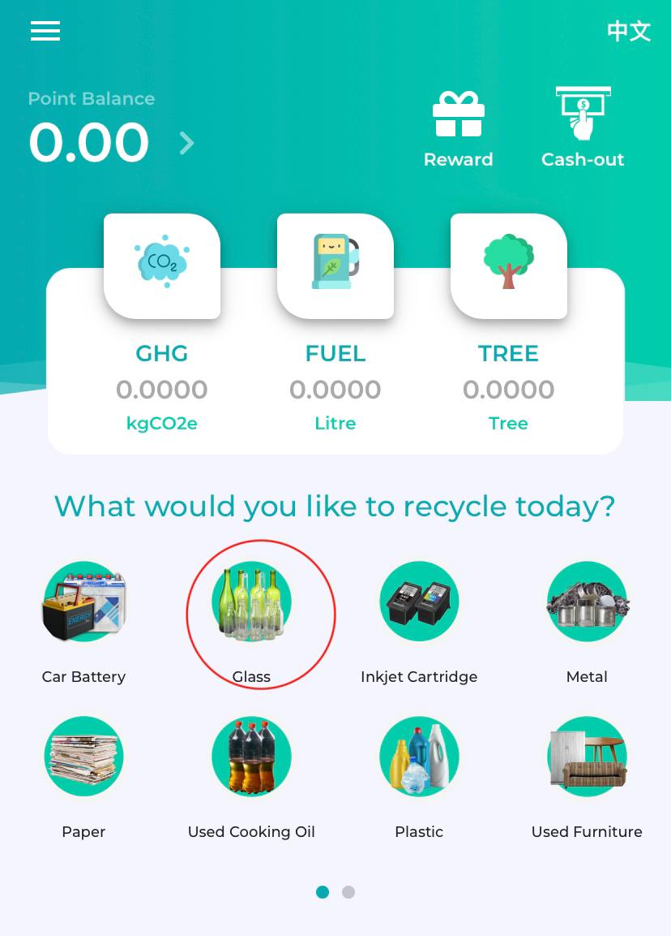
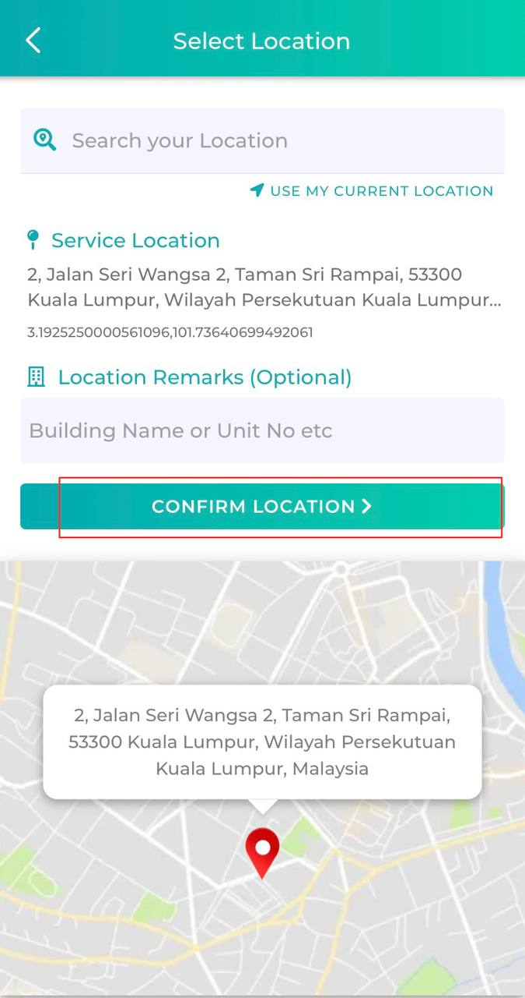
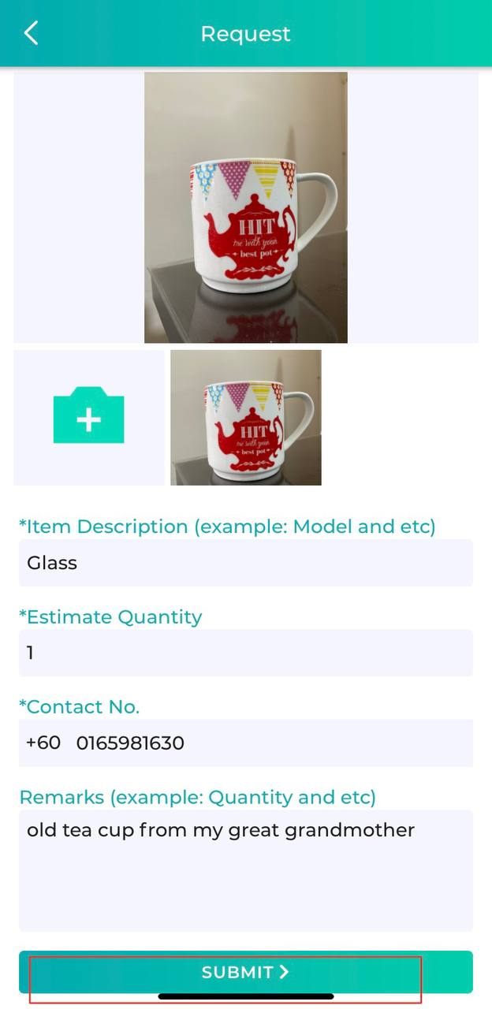

What is the feature?
The feature is called ‘What would you like to recycle today?’ which is the main recycling feature of this app.

What is the target behaviour?
The target behaviour is to make the user submit a request for their item to be recycled which goes through two interfaces in the beginning which is the homepage and the location selector.

- Ability
There are a lot of reasons as to why this feature is a high ability feature in my opinion. Firstly, the time concern is not an issue as I am able to submit a request in less than 20 seconds. Next, the physical effort is very minimal as the feature is at the homepage which pops up as you launch the app. Not to mention everything is done through your smartphone and you just need to tap a few buttons for the whole process. The last reason is how this feature affects our “brain cycles”.
The Recircle app does not require you to complete a CAPTCHA or authenticate your account through an email before recycling thus not making the user think very hard and complicating things.

- Motivation
Now let's discuss the motivational side of this feature which makes this a high motivation feature. The main motivator of this feature is the pleasure that comes with recycling using this app. With every recycle you earn points on your account which you can then exchange for money that scales up with every 100 points equaling RM1. You are also rewarded with vouchers that can be used on other apps and services. Next, the fear of climate changes and environmental issues is a large motivator for this feature. Society realises that if we do not do something to prevent climate changes and its impacts such as the thinning of the ozone layer, Earth will be a disaster for our children and the next generation that follows. The users hope by using the recycle feature, they might be able to change the fate of the environment. Lastly, social acceptance is also a main motivator that aids this feature. We as humans subconsciously seek social acceptance and try to fit in with ideologies that the majority believe is correct, even when deep down we personally do not agree with the ideology. If everybody uses the Recircle app instead of the trash can, would you still use the trash can? The fear of rejection will probably overwhelm you into using the Recircle app.

- Triggers
The trigger actually is in the name itself which is the question “What would you like to recycle today?”. The question grabs the user’s attention as the sentence lingers in their brain and combined with the high ability of this feature should be enough to place the user above the behaviour activation threshold. This utilises the Spark as Trigger aspect and it is presented to the user before the user takes action.

c) short video demonstration on how the user is persuaded to execute a “target behaviour”
[videos are provided in a compressed folder].

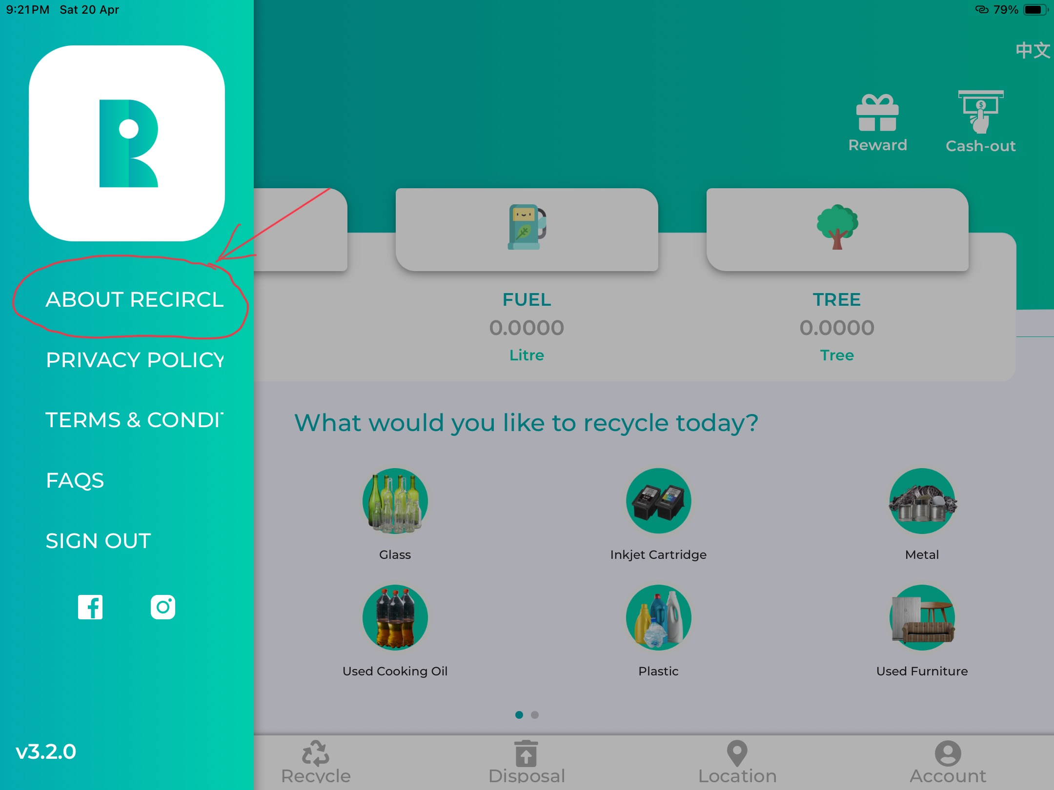
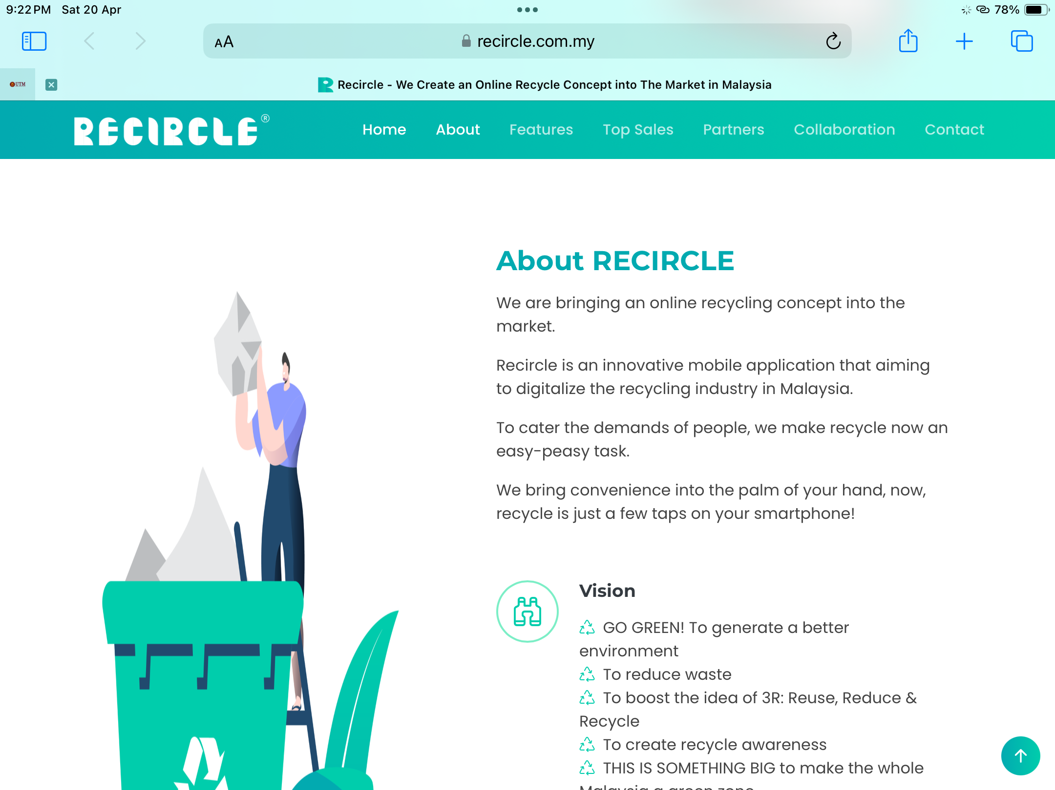
d) a feature that fail to persuade a target behaviour

I think one feature that fails to persuade a user to execute the target behaviour is on the “about Recircle”. Each user are brought to the external website to read about the history about the apps.Most of the user will tend to not getting back to the app as they are brought to outside the apps.The user may lose interest just after reading the history of the apps and they will continue to surf their social media app such as Whatsapp and Instagram.

The suggestion that can be implement to solve this are by providing all information or history about the Recircle apps just in one place.Moreover,the app developer with designer should design the history site as simple as it can.This should be done as most of the user tend to read not more than 1 paragraph text only.If more than that,the user will just scroll away and find something that will catch their eyes.

In a similar way, if a design team finds that website visitors are not performing a behaviour designers intend, they can use the FBM to figure out what’s missing.

